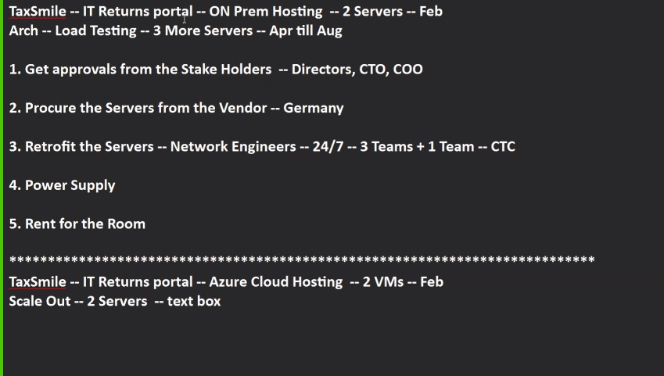

**TaxSmile IT Returns Portal Hosting & Scaling**

**1. On-Premises Hosting Setup**

* TaxSmile’s application is hosted **on-premises** in Wipro’s server room, currently using **2 physical servers**.
* Since Wipro has a large infrastructure, scaling is possible by adding more servers as needed.

**2. Load Testing and Scaling**

* As the architect, you performed **load testing** and found that during **peak months (April to August)**, traffic increases significantly.
* To handle this, you decided to **scale out** by adding **3 more servers**, increasing the total to 5. This ensures smooth performance during busy tax filing periods.

**3. Stakeholder Approval**

* Before buying and installing new servers, you must get **approval from key stakeholders**: Directors, CTO, and COO.
* This ensures everyone is aligned on budget, timeline, and technical needs.

**4. Procurement**

* Servers will be purchased from a trusted **vendor in Germany**, ensuring quality and delivery timelines.

**5. Retrofit & Installation**

* **Network Engineers** will retrofit the servers into the server room, including cabling, network setup, and testing.
* Since the server room runs **24/7**, multiple teams (3 teams for installation + 1 team for support) will work in shifts.
* This also involves costs related to manpower, called **Cost to Company (CTC)**.

**6. Power Supply & Rent**

* The server room requires **consistent power supply** supported by backup systems like UPS and generators to prevent downtime.
* There’s also a **monthly rent for the physical space**, covering power, cooling, and security.

**Azure Cloud Hosting Explanation**

* Instead of physical servers, you can use **Azure Cloud Hosting**, where you start with **2 Virtual Machines (VMs)** in February.
* When traffic spikes, you can **scale out easily by increasing the number of VMs**, for example from 2 to 5.
* This scaling is fast and can be done by changing a simple **configuration or text box**.
* After peak periods, you can **scale back down to save costs**.
* Azure handles the physical infrastructure, so you don’t worry about power, rent, or hardware maintenance.

**Cloud Computing**

***“Cloud computing is a style of computing where scalable and elastic IT-enabled capabilities are delivered as a service to external customers using Internet technologies."*  
— Gartner**